[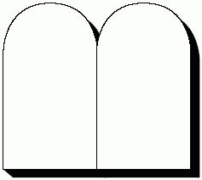](https://www.google.com/url?sa=i&url=https%3A%2F%2Fwww.pinterest.com%2Fpin%2F138204282291185985%2F&psig=AOvVaw3w8EPsNxE8s1azhJ12s1Wt&ust=1630158032593000&source=images&cd=vfe&ved=0CAcQjRxqFwoTCNCM_cup0fICFQAAAAAdAAAAABAE)

**Love**

**Others**

**Love**

**God**

[](https://www.google.com/url?sa=i&url=https%3A%2F%2Fwww.pinterest.com%2Fpin%2F138204282291185985%2F&psig=AOvVaw3w8EPsNxE8s1azhJ12s1Wt&ust=1630158032593000&source=images&cd=vfe&ved=0CAcQjRxqFwoTCNCM_cup0fICFQAAAAAdAAAAABAE)

**Love**

**Others**

**Love**

**God**