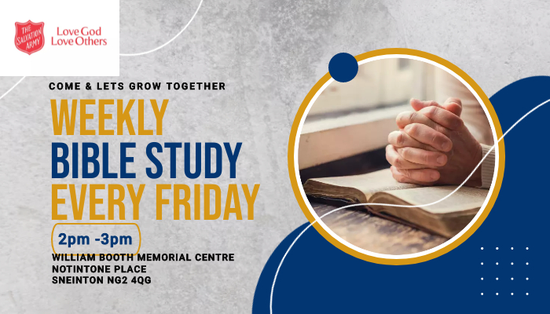

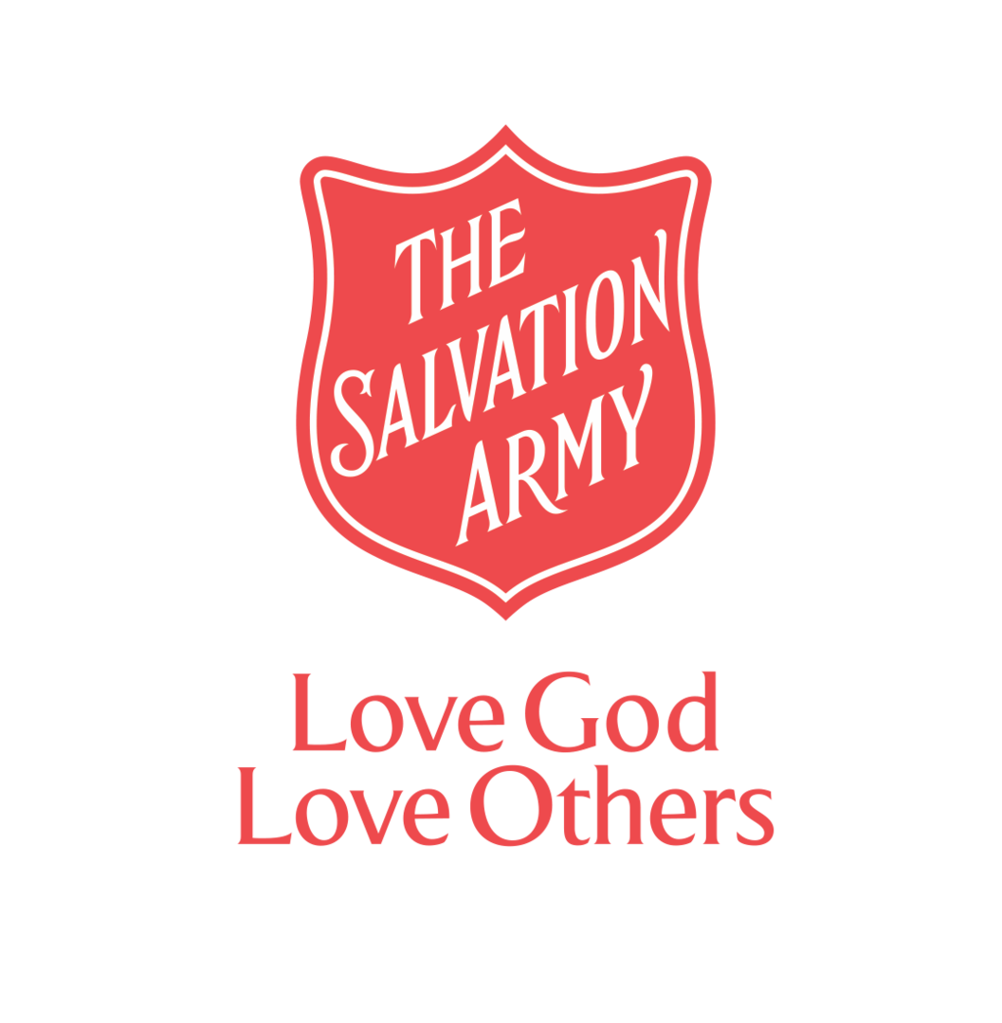
In Tune with Notintone
November 2023

WHO ARE OUR NEIGHBOURS? FAMOUS SON PREACHER
"Love the Lord your God with all your heart and with all your soul and with all your mind and with all your strength. The second (Commandment) is this: Love your neighbour as yourself. There is no commandment greater than these." (Mark 12:30,31)  As part of our reaching out to our neighbours, we discovered that there were over 100 people in Sneinton who are waiting for Basic English classes. As a result, we have linked with the BELONG charity to host ESOL classes on a Monday & Wednesday afternoon.  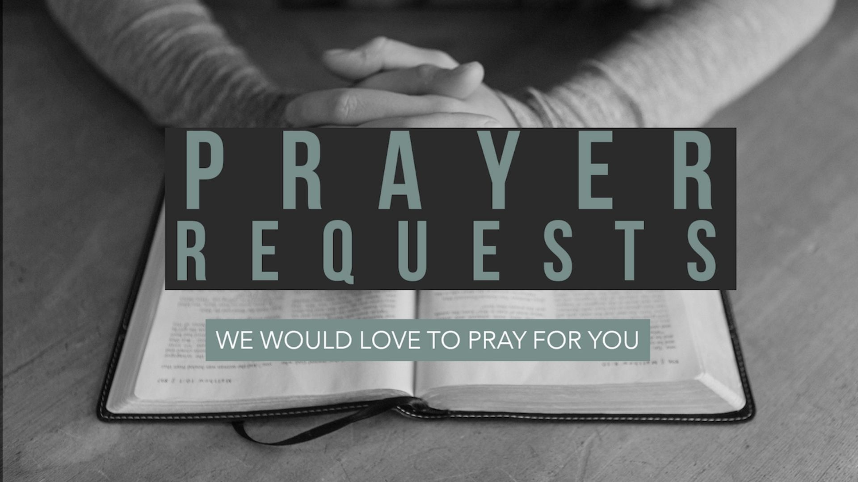  . Living On a Prayer  We begin every week with Prayer for our Community. Please share any Prayer Requests you have with us and we will include them in our weekly Prayer meeting on Mondays at 9am, |  | 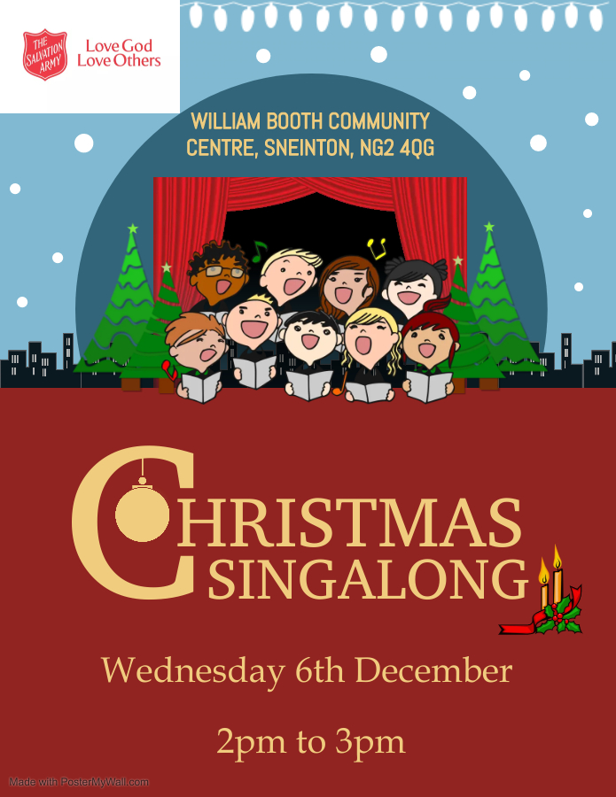  .
Contact: Community Mission Manager, Ian Young
Email: Ian.Young@salvationarmy.org.uk
Tel: 07587348459
Facebook: www.facebook.com/WBoothCentreSneinton
The Salvation Army, William Booth Memorial Complex, 14 Notintone Place, Sneinton, Nottingham. NG2 4QG

