Ramsgate Salvation Army
Sunday 9th April 2023

A warm welcome as we gather as the family of God today,
especially if you are not normally with us on a Sunday.
May we all feel the welcome of God and each other.

We meet at The Salvation Army Hall Sunday 10.30 am.
Also Sunday worship is livestreamed on
You can find a link on the Ramsgate Salvation Army Web page
www.salvationarmy.org.uk/ramsgate

Today , Easter Sunday, we will join millions of Christians around the globe with these words’
“Christ is risen!”
“He is risen indeed!” Hallelujah
Why do we say these words? From where did this practice come?
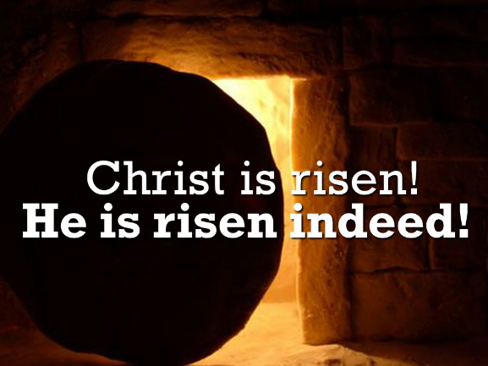
It has been a custom since the early church. These words are also used by individual Christians as they greet each other on Easter Sunday. In some cultures, this is accompanied by the exchange of three kisses on alternate cheeks. (….not at Ramsgate Salvation Army I hear you say with terror!)
We should not dismiss these words as a useless, empty tradition. The Paschal Greeting is biblical. It is based on passages from the gospel accounts of Christ’s resurrection when angels reported the good news to the disciples – and the disciples to one another – that Christ had risen (see Matthew 28.6-7; Mark 16.6; Luke 24.6, 34).
The glorious words, “He is risen indeed!” is the best news we can hear in this life.
They remind us that Christ’s suffering and death on the cross was not in vain, but in fact accomplished our redemption. “Christ is risen!” is an exclamation of His victory over Satan, death, and hell. For centuries, Christians have exchanged these joyful words on the annual celebration of our Lord’s resurrection.
Today is Easter Sunday. As we worship together as a church family, let’s say with joy in our hearts and as saints have done for centuries, “He is risen indeed!” As we greet one another today, let’s bless one another with the good news, saying, “Christ is risen!” “He is risen indeed!”

Loving Lord,
Today we remember the veil of darkness transforming to the brightest light. The most dreadful end becoming the most beautiful beginning.
We remember with trembling hearts the depths of despair fading to reveal hope everlasting.
The curse of death defeated by eternal life.
Today we remember with thankfulness your willingness to be pierced for our sins.
We sing with abounding joy of your miraculous rise, from death’s tomb to resplendent life.
Thank you for the promise of heaven and your generous invitation of eternal life for all.
Amen.
What’s happening at Ramsgate Salvation Army?

Sunday 9 April 9.00 Easter Breakfast
10.00 Prayers
10.30 Easter Sunday Celebration

This week Carl, Heather, Jacqueline, John and our amazing volunteers are taking some rest.
Monday to Friday (6.30am-9am) Breakfast Drop-in
Monday (9.30 am – 11.30 am) No Little Fishes (Parent & Toddler group)
No ACEs this week
No membership classes
Tuesday No Prayers (9.30am)
No Food Parcel preparation
No Well – nor warm welcome.
No Light Lunch (12 noon)
No bible study
No ZOOM bible study
Wednesday (from 11 am) No Friendship club and Lunch club
Speak-Up using community hall.
Carl conducting the funeral of Sue Shilling
Thursday Forward Trust at Hall

Friday (10am - 12 noon) Food Bank
Ukrainian Language Class (1.30pm)
No Kids Club (6pm to 7.30pm)
Saturday Ukrainian Drop-In (11am to 1pm)
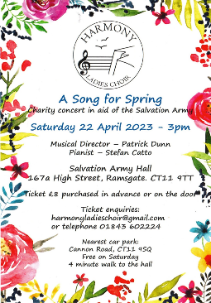
Sunday 16th 10.30 Sunday Worship

A Song for Spring
22nd April 3pm
In aid of Ramsgate
Salvation Army
Flowers this Sunday are thanks to Janet

Birthdays and Celebrations

Leah Pearce Sunday 9-Aprilil
Muriel Beckett Tuesday 11-April
Douglas Mackinney Tuesday 11-April
Stephen Mills Saturday 15-April
Samantha James Sunday 16-April

We continue to pray for Gran and Cheryl and family and friends of June James . Carl will conduct her funeral on 25th April.

We continue to pray for the family and friends of Chris Barton from Ramsgate Town Council following his recent death. Chris was a great friend of the corps and provided much support and encouragement.

We think and pray for the family of Sue Shilling, Carl will conduct her funeral on 12 April.

Our prayers continue for Major Kathryn Blowers and for her family as they care for her.

We pray for Captain Jan Penfold that she might soon be back to full health.
We uphold Kathryn Bance and ask God to meet her needs. We pray too for Daniel
We continue to pray for John McCairn. John’s recent procedure was not successful and he is waiting for an appointment at Kings College Hospital.
Prayers for Josette whose recent fall has left her very weak and in much pain.
We pray for Peter Ford and Cheryl Yates who are all unwell.
Prayers for Douglas as he continues to battle with complex issues. May God give Him healing, strength and wisdom he needs.
We thanks God that we saw Isobel on Wednesday and pray she will continue to get better. We also uphold Janet’s son Richard. We remember in prayer Angela’s sister Teresa. Finally but not finally for Sue Layton who has been unwell the last few weeks and waiting for care.

