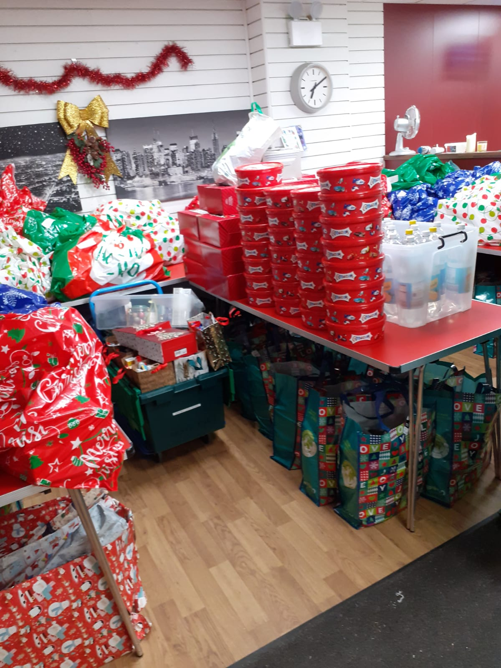
Christmas 2022
Thanks to donations from the local public, our team was able to prepare parcels of gifts, food and toiletries for many local families. As Christmas Day approached, the demand was twice as high as we had prepared for – but still there was enough to give.

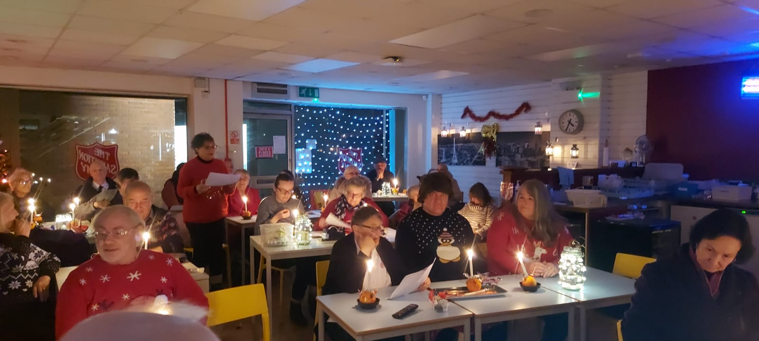
On Sunday 18th Dec we made Christingles and then used the lit candles to sing the Christmas story as children brought forward the characters to make up the nativity scene. A highlight was the children singing Away in a Manger – completely unrehearsed.

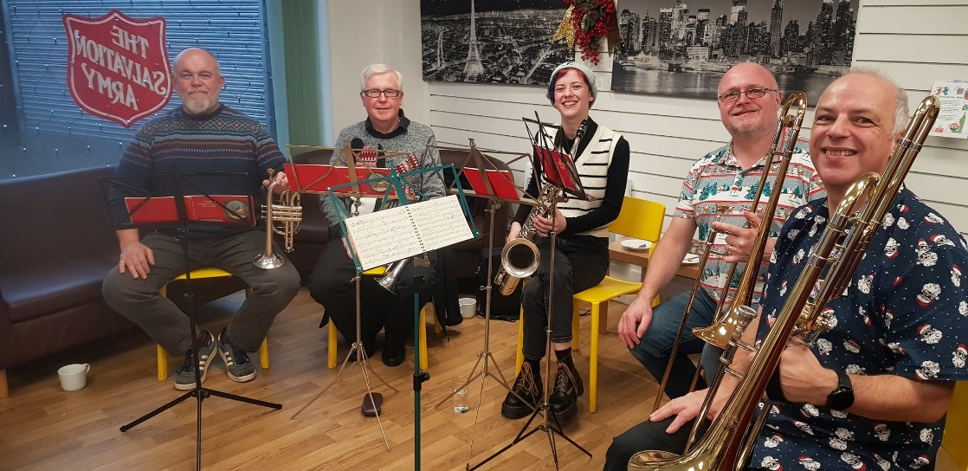
Some bandsmen from Royal Buckley Town Band provided the accompaniment for a Friday afternoon ‘Carols in the Coffee Shop’, there was barely a free seat in the room as people chose their favourite Carol, or Christmas Song and joined in singing heartily as we remembered together that first Christmas.

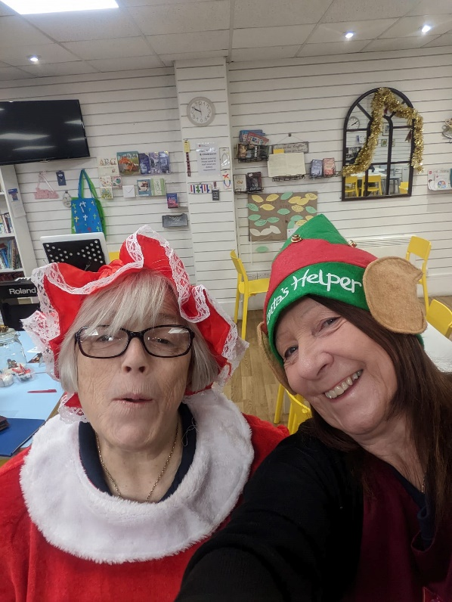
We give thanks to our great team of workers – dressed for most of December in Christmas cheer and spreading something of God’s love to everyone who came into our shop. 