Chapter 9:
Called to the wild – crying in the wilderness
Based on Isaiah 40:3–5; Malachi 3:1, 4:5; Matthew 3:1-17, 11:1-30; Luke 1:13-17; John 1:19-25, 3:22-36

This month’s content is written by Major John McLean, corps officer at Maidenhead Citadel and member of the UKI Territory Prayer Strategy Team.

INSPIRE

Picture the scene: a bunch of ‘celebrities’ are put into a secret location and, after a couple of weeks, helicoptered into the Australian wilderness and given tasks and challenges that will stretch them. All of this is so we can vote on who should win the game. Hardly an exciting choice, but we’re told it makes good television, and if we’re honest we probably enjoy seeing celebrities suffer as they are challenged to eat insects, touch creepy crawlies and swim with crocodiles!
In our present circumstances, it can feel like the wild is a place to be overwhelmed and overcome. Yet in Chapter Nine of our ‘Into the Wild’ adventure we meet John the Baptist, a man who literally lived out his life and ministry in the wild … and bore fruit.
In a hurting world, it is easy to ignore the ‘God prods’ – the clear messages he wants us to proclaim and speak out. But we learn from John the Baptist that to fulfil our calling we must speak truth into difficult situations, showing compassion and care while pointing clearly to Christ who can bring wholeness and deliverance.
Read alone or with a friend, reflect on the discussion questions over the phone with someone or in an online small group / Bible study, try the prayer activities … and see what happens when you commit to God in the wilderness.
If you’d like to receive regular updates throughout the ‘Into the Wild’ journey over the coming year, including invitations to our regular Zoom prayer gatherings, sign up here.

EXPLORE

Introduction
When we think of the desert, we often think of it as a negative experience. We see the heat, the dryness, the lack of water and vegetation as something to be feared and avoided at all costs. In this picture of the desert, we meet John the Baptist, a prophet and a person so eccentric that, if we were to encounter him, we would probably head the other way. His clothes were odd, and his diet was certainly like a challenge from I’m a celebrity… get me out of here! Who would choose a diet of locusts and wild honey?

Context
John’s aim was not to be the stereotypical prophet or the oddest person around. His aim was to be obedient to the call of God on his life. It was prophesied by Isaiah that he would be the forerunner of Jesus, and in the Gospels we encounter him fulfilling the prophet’s words and playing the specific role God had ordained for him. John had no power or position within the Jewish tradition, but he spoke with a compelling authority.

As John called those who heard him to ‘Repent, for the kingdom of God is at hand,’ their response was often to crowd around him; but he always pointed beyond himself to the coming Messiah, Jesus Christ.

Refined
John’s ministry in the wilderness challenged his hearers to repent. As we journey into the wild, are we being invited to be REFINED? As people of prayer, we can often plod on with our own agendas and plans, displaying a pious response to others’ failures whilst ignoring our own.

About eight years ago I found myself in the place of the desert. It was an experience I would have chosen to avoid if I could, but with hindsight I daily thank God for the Spirit’s work of refining in that season. If we want to go on a journey of radical discipleship, allowing ourselves to be used by God, we are likely to need to begin with the refining process.

The word ‘repentance’ in John’s context was a challenge and invitation to a complete U-turn, a change of direction.

Relationship
In our wilderness experience as people of prayer we must never neglect the calling of God to point people to Jesus. It is something John did all the time, and many commentators have noted it, wondering why he did it so consistently.

John’s life was defined by his obedience to the will of the Father. He knew where he was positioned in RELATIONSHIP to Jesus. As he ministered and called the people to repentance and baptism, he was fulfilling the calling of God that began before his conception and continued until Jesus’ baptism.

In our wilderness experience, could it be that we are being reminded of our relationship with our Father God and the purpose of pointing others towards relationship with Jesus? The Salvation Army needs a fresh release of the prophetic – not a random self-serving message, but one that, like John the Baptist’s, calls us into intimacy with the Father. Dare I suggest that the world needs God’s prayer warriors to be deeply connected to the Father’s heart, walking humbly in declaring the Kingdom?

Reach
As John prepared the way for Jesus’ coming, his message was missionary in impact: inviting people to give up their sinful ways; to reject religiosity; and to respond to the Kingdom. John’s message reached beyond the norms of the day. The calling of God in prayer is to move the focus away from inward-looking fulfilment – it is to REACH beyond ourselves.

Deepen
This year in the ‘wilderness’ has invited us to rethink not only why we do what we do in our corps and communities, but also how we fulfil the calling of God to reach the world and point people to Jesus. There have been many stories of corps and churches making an impact by moving beyond their halls, learning that it isn’t about inviting people to our clubs but allowing people to encounter Jesus through us.

It is easy to focus on John the Baptist’s role as the preparer of the way for Jesus’ coming. Yet if we choose to dig a little deeper, we discover that this wild-looking man’s message was irresistible to the listeners.

In our own wilderness, when the usual rules and routes for pointing people to Jesus aren’t as usable, could it be that God is giving us the opportunity to rediscover his voice and to listen to him afresh? Is he challenging us to declutter our hearts? Are we being encouraged to redefine what reaching others is truly about?

Conclusion
We are called as disciples to ‘the 3 Rs’: to be REFINED through repentance, to recognise RELATIONSHIP found in Jesus and to respond to the REACHING out of God’s message. As people of prayer, God is inviting us in our wilderness to allow his Spirit to refine us, to remove those things that get in the way of his ministry through us. He wants us to know his heart and to invest more deeply in our relationship with him. It is an incredible privilege that we can hear his voice and that we can invite others to know Jesus, the one whose presence is peace, healing and hope, even in these difficult times.

A truth to hold on to
God has brought us to the wilderness to say something to us.
Challenge
- Next time you talk to someone who is struggling, instead of suggesting solutions, lead them to Jesus in prayer.

WATCH

This month's video is a beautiful piece by Beth Parker on the joy she finds in wild swimming and what it's teaching her about prayer in the wild.
Watch this video here

DISCUSS

- Which of the three Rs has been your experience during this wilderness time: refining, re-investing in relationship with Jesus or reaching out to others in the love of God? What have you learnt?
- God’s work of refining can feel more painful than liberating. Why do you think this is? What lessons would you share with others who are finding God’s purifying work to be painful or costly?
- The challenge of hearing the voice of God can be difficult in different seasons of life. What can we do to allow God to speak to us and how can we make sure that we invest in deepening our relationship with the Father?
- Have you ever heard the voice of God but were worried about sharing because it wasn’t a comfortable idea? What did you do to overcome the discomfort?
- Have you ever been told by another that you had shared something that was encouraging or a message from God for them? What was the situation?
- As John the Baptist’s message called people to repentance, he also consistently pointed to Jesus. How can we reach out and point others to Jesus in this season?

PRAY

1. Handwashing
Bring a bowl of water and some soap to your prayer time. As you spend time in repentance before God, wash your hands as a way of remembering that you are cleansed by the blood of Jesus.

2. Transformation timeline
Using paper and colouring pens, take time to think through the past year. Draw a timeline across the page, highlighting the highs and lows of your journey. Allow God to show you where he has been refining you and celebrate his work in your life.

3. Music meditation
Choose some prayerful worship music to play, get comfortable and invite Father God to help you sense his presence in your space. As you listen to the music, ask him to speak to you. Choose to dig deeper in getting to know his heart.

4. FRANC prayer cards
Use a ‘FRANC’ prayer card (templates below). After adding a name in each area, spend time in prayer for each person, praying for their understanding of God to grow. Ask God to give you a word for them.
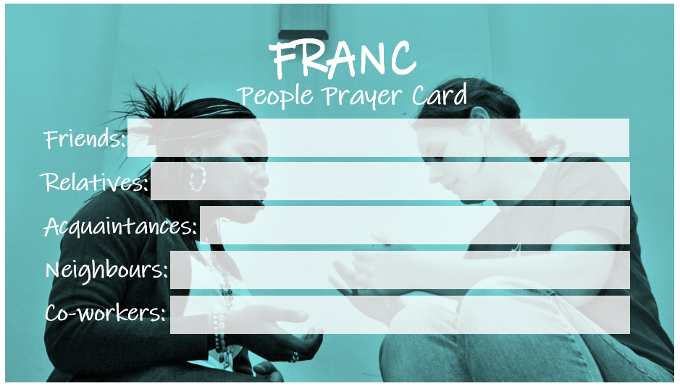
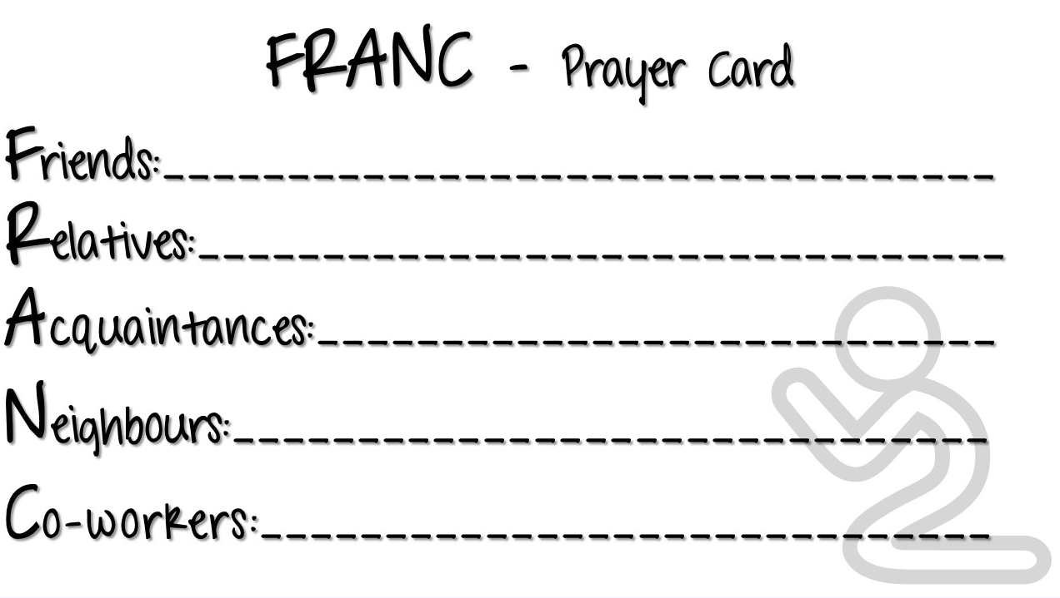

WEBSITE AND CONTACT EMAIL
For resources and sign up: www.salvationarmy.org.uk/resources/into-the-wild
Email Prayer Network: saprayernetwork@salvationarmy.org.uk

