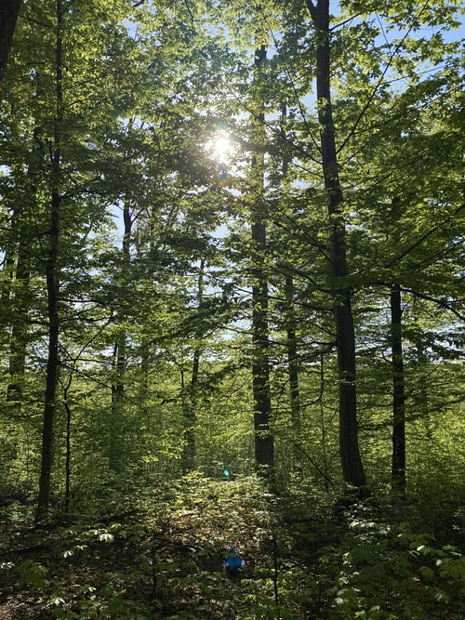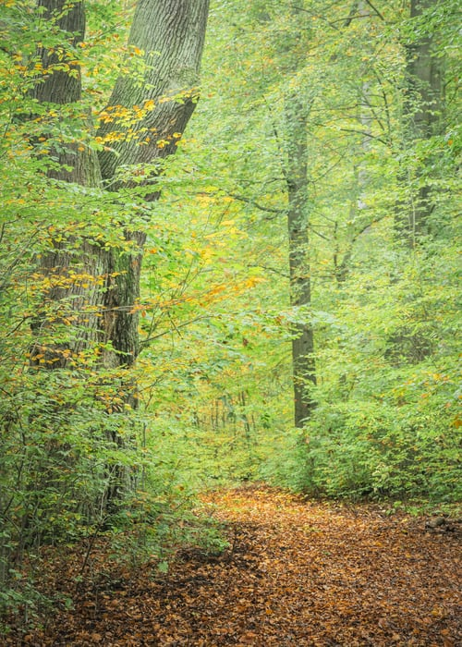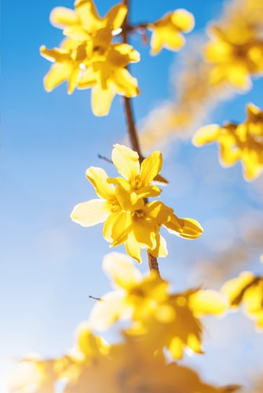

GO WILD, EXPLORE, PLAY & DISCOVER WITH FUN OUTDOOR ACTIVITIES

****Insert corps name*****  
The Salvation Army is a Christian Church and registered charity in England   
and Wales (214779), Scotland (SC009359) and the Republic of Ireland (CHY6399).

**GE T OWT!**

INSERT DAY

****am – ****pm

LET NATURE NURTURE YOUR LITTLE ONES

**O**UTSIDE **W**ITH **T**ODDLERS