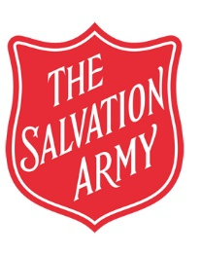 | The Salvation Army  United Kingdom Territory with the Republic of Ireland  Coronavirus task force response document  Coronavirus Pandemic Event Decision Sheet | Issued:  Review by: Assistant Chief Secretary

Event Name:
Date:
Points to consider | Response
Key dates
- Cancellation policy
(when does balance become due/ when can deposit be recovered etc)
- When will travel to event begin for delegates
- Is there insurance in place to cover costs?
- Method of refund?
What is the purpose of the event?
Is it essential?
Can it be postponed?
What will be lost if this doesn’t go ahead?
Could the number of delegates be reduced?
Are any external speakers/performers scheduled to attend?
How many people are involved?
Where will they come from?
Local to the venue?
International?
What is the corona virus ‘risk profile’ of attendees?
Age ranges
Underlying health issues?
What is the format of the event?
(small group discussions/ lectures / workshops)
How much social interaction will there be?
Can social distancing be used to reduce effects?
How will people travel to the event?
(e.g. Fly / train/ bus / private car)
How many will use each form of transport?
Do we have enough staff to cover the event?
(staff sickness etc)
Are there alternative methods of hosting this meeting?
(e.g. Lifesize / conference call etc)
What other methods would be possible?
What equipment / resource would be needed?
Could the event be held at a later date?
Will this have any knock on impacts to other activities or meetings?
When would be a suitable date to reschedule?
Final decision and justification.

Date:

Leadership Decision:
Date:

Sign off:

Service event reviews should be approved by the relevant Service Head.
Reviews of divisional events should be approved by Divisional Leaders.

