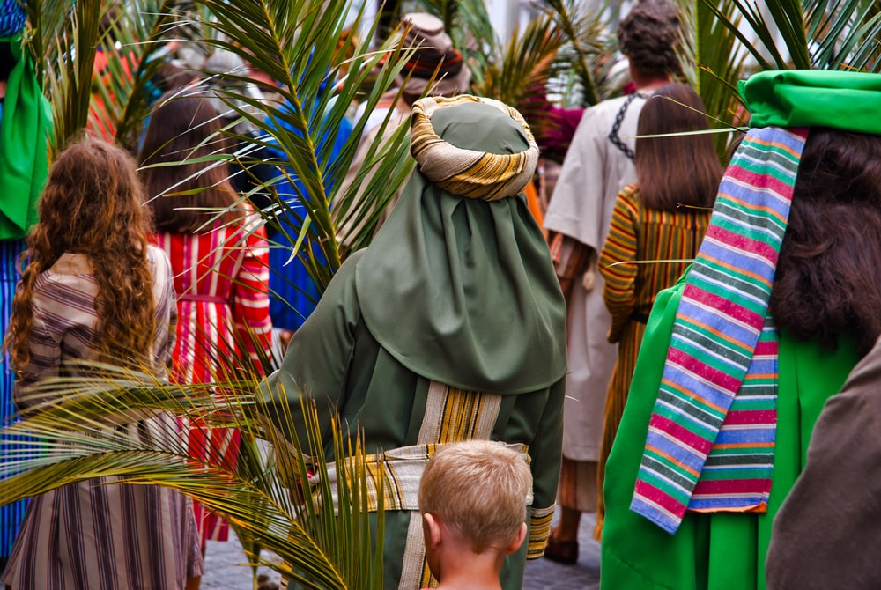
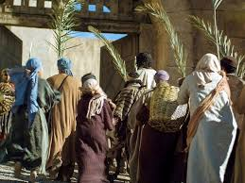
Welcome to Worship

‘Palm Sunday - The Triumphal Entry’

‘Come, let us Celebrate – Hosanna in the Highest’

The Coming of Zion’s King
Rejoice greatly, Daughter Zion!
Shout, Daughter Jerusalem!
See, your king comes to you,
righteous and victorious,
lowly and riding on a donkey,
on a colt, the foal of a donkey.

Zechariah 9:9

Song 196 ‘Ride on, ride on in majesty…’

Ride on, ride on in majesty!  Hark, all the tribes hosanna cry;  Thine humble beast pursues his road  With palms and scattered garments strowed.  Ride on, ride on in majesty!  In lowly pomp ride on to die;  O Christ, thy triumphs now begin  O’er captive death and conquered sin.  Ride on, ride on in majesty!  The winged-squadrons of the sky  Look down with sad and wondering eyes  To see the approaching sacrifice. | Ride on, ride on in majesty!  Thy last and fiercest strife is nigh;  the Father on his sapphire throne  expects his own anointed Son.  Ride on, ride on in majesty!  In lowly pomp ride on to die;  Bow thy meek head to mortal pain,  Then take, O God, thy power, and reign.  Henry H. Milman

Palm Sunday is the beginning of Holy Week, and Jesus’ entrance into Jerusalem. Palm branches were placed in His path as He approached the entrance to Jerusalem on His donkey. People in the middle-east place a cover across the path of someone esteemed and worthy of honour. When we see the Palm Branch, we are reminded that it was a Jewish symbol of victory and triumph. So the Palm Branches strewn across Jesus’ path signified the coming Messiah, the fulfilment of the hopes of Jerusalem.

Song 148 ‘Make way, make way, for Christ the King…’

Make way, make way  For Christ the King  In splendour arrives.  Fling wide the gates and welcome Him  Into your lives.  Make way! (Make way!)  Make way! (Make way!)  For the King of kings.  (For the King of kings)  Make way! (Make way!)  Make way! (Make way!)  And let His kingdom in. | He comes the broken hearts to heal,  The prisoners to free.  The deaf shall hear, the lame shall dance,  The blind shall see.  And those who mourn with heavy hearts,  Who weep and sigh;  With laughter, joy and royal crown  He'll beautify.  We call you now to worship Him  As Lord of all.  To have no gods before Him,  Their thrones must fall!  Graham Kendrick
Bible Reading – Matthew 21:1-11

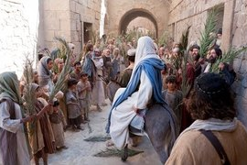
Jesus’ Triumphal Entry into Jerusalem’

As they approached Jerusalem and came to Bethphage on the Mount of Olives, Jesus sent two disciples, saying to them, “Go to the village ahead of you, and at once you will find a donkey tied there, with her colt by her. Untie them and bring them to me. If anyone says anything to you, say that the Lord needs them, and he will send them right away.” This took place to fulfil what was spoken through the prophet:

“Say to Daughter Zion,
‘See, your king comes to you,
gentle and riding on a donkey,
and on a colt, the foal of a donkey.”

The disciples went and did as Jesus had instructed them. They brought the donkey and the colt and placed their cloaks on them for Jesus to sit on. A very large crowd spread their cloaks on the road, while others cut branches from the trees and spread them on the road. The crowds that went ahead of him and those that followed shouted,

“Hosanna to the Son of David!”
“Blessed is he who comes in the name of the Lord!”
“Hosanna in the highest heaven!”

When Jesus entered Jerusalem, the whole city was stirred and asked, “Who is this?”

The crowds answered, “This is Jesus, the prophet from Nazareth in Galilee.”

Prayer for Palm Sunday by Colin Fairclough

O God, our loving Father, on this Palm Sunday we gather in the name of the lowly Jesus, your Son. On this day we recall that he entered Jerusalem, the King coming to his own.

The world would have had him riding in triumph, leading a mighty army. In your word, Father, we read that he sat upon a borrowed donkey, and that those who followed him were a crowd of very ordinary people. We hear their cries of 'Hosanna', and we join our voices to theirs. But, O God, we know because we can look back, that many of those who acclaimed him as King so soon rejected him, mocked him, crucified him. Make us aware, we pray, of how easily we can be led from loyalty to denial, from commitment to indifference. The voices of the world are so strong, and we are so often afraid to be a small voice speaking out for Jesus, the gentle King.

On that first Palm Sunday, Father, your Son wept as he approached Jerusalem. We know only too well that he still weeps as he sees what we have done and what we have failed to do in his world. There is injustice and intolerance; war and aggression; greed and envy and selfishness and smugness; children are hungry and women weep and men live in fear of one another. The world is waiting for its King, its Light, its only Saviour. May it know him when he comes!

Today, yet again, may we with the angels 'Look down with sad and wondering eyes to see the approaching sacrifice.'

Song 366 ‘Hosanna, hosanna, hosanna in the highest…’

Hosanna, Hosanna, Hosanna in the highest  Hosanna, Hosanna, Hosanna in the highest  Lord we lift up Your Name,  With hearts full of praise,  Be exalted Oh Lord our God,  Hosanna in the highest. | Glory, Glory, Glory to the King of Kings  Glory, Glory, Glory to the King of Kings  Lord we lift up Your Name,  With hearts full of praise,  Be exalted Oh Lord our God,  Glory to the King of Kings.  Carl Tuttle
Bible Reading – Luke 19:41
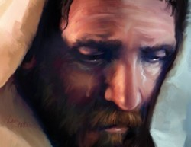
Jesus weeps over Jerusalem

‘As he approached Jerusalem and saw the city, he wept over it.’

The Gospels of Matthew, Mark and Luke give the accounts of Jesus riding into Jerusalem on the donkey, and people shouting Hosanna, and praising His coming’ Luke in his account brings into his account of the entry a verse which says, ‘Jesus wept over Jerusalem’. Why?

The people were expecting a hero who was going to save them from the tyranny of the Romans. Jesus did come to save the people, but not in the way that they had expected. Jesus was a personal Saviour who had come to save people from their lives of sin. The people weren’t accepting of this. Jesus loved them and wept for them.

The celebrations soon stopped, the Hosanna’s stopped. Jesus did not meet the people’s expectations, and a couple of days later, they were shouting, ‘Crucify Him, Crucify Him.’

Song 465 ‘I heard of a Saviour whose love was so great…’

I heard of a Saviour whose love was so great  That he laid down his life on the tree;  The thorns they were pierced  on his beautiful brow  To pardon a rebel like me. | He pardoned a rebel, a rebel like me,  He pardoned a rebel like me.  The thorns they were pierced  on his beautiful brow  To pardon a rebel like me.

They tell me he wept over sinners one day  Saying: O that your Saviour you knew!  How oft would I gather you under my wing  And pardon poor rebels like you.  O love so amazing that broke my hard heart  And brought me, dear Jesus, to thee! | I know, when I came, thou didst not cast me out  But didst pardon a rebel like me.  'Tis true that poor sinners of all kinds he saves,  And you he will not cast away;  He waits in his mercy sweet peace to bestow,  So come to the fountain today.  Stuart Townend

Prayer Lord God, as we sing our ‘Hosanna’ today,
may we remember also what you were riding toward:
the suffering and rejection,
pain and humiliation, the cruel cross.
And let us look forward to the joy of Easter Day
when you rose from death to reign for ever.
Help us, as we daily lay our lives before you,
To live the resurrection life that acknowledges
Jesus as Lord and King over our lives. Amen

John Birch

Today:

- Give ‘Thanks’ to God for His precious gift of Jesus His only Son, to be the Saviour of the World.

- Pray for each other and our families.

- Pray for our Country and Government Leadership, that we may be governed with wisdom and integrity.

- Pray for the Church worldwide, that it may be obedient to the Word of God, and guided by God’s Holy Spirit.

Song 32 ‘How deep the Father’s love for us…’

How deep the Father's love for us,  How vast beyond all measure!  That He should give His only Son,  To make a wretch His treasure.  How great the pain of searing loss!  The Father turns His face away;  As wounds which marred the Chosen One  Bring many sons to glory.  Behold the man upon a cross:  My sin upon His shoulders;  Ashamed I hear my mocking voice  Call out among the scoffers. | It was my sin that held Him there  Until it was accomplished;  His dying breath has brought me life –  I know that it is finished.  I will not boast in anything,  No gifts, no power, no wisdom;  But I will boast in Jesus Christ,  His death and resurrection.  Why should I gain from His reward?  I cannot give an answer;  But this I know with all my heart –  His wounds have paid my ransom.  Stuart Townend

Benediction Now may the Lord of peace
Himself give you peace,
Always in every way.
The Lord be with all of you.

(2 Thessalonians 3:16)

