Easter Gifts
SPECIAL DAYS

PREPARATION
- Six gifts wrapped in Easter paper with the following written on the tags: forgiveness, freedom from fear, joy, peace, eternal life, mission
- A small Easter gift for each member, for example: bag of mini eggs, bunch of daffodils, small hand cream
- Melted milk chocolate, cornflakes and mini eggs to make Easter nest cakes, bowl, wooden spoon, cake cases
- ‘Easter Questions’ poem (see below) – perhaps ask a member to prepare a reading
- Prepare an Easter quiz (see below) and offer a small prize

- Ask your group to have the baking ingredients and equipment ready at home, or you may wish to provide these
- Email the ‘Easter Questions’ poem
- Email the Easter Quiz or search for an online quiz that will suit your group, for example: a food-based quiz, a trivia-based quiz or a Bible-based quiz
- Drop off a small Easter gift
Additional resource:
- ‘Easter Questions’ poem
- Easter Quiz

INTRODUCTION/BACKGROUND
Other than Easter eggs, do you ever give presents at Easter? For some reason we don’t seem to give gifts at Easter in the same way we do at Christmas. But surely there is no greater celebration for Christian people than the fact that Jesus died for our sins and rose again. He is alive!

While we may not give and receive presents with other people, Easter does bring God’s people many gifts, and we are going to look briefly at just some of them in this session.)

ACTIVITIES
MAKE
Make simple Easter nest cakes using melted chocolate and cornflakes. Do a cooking demo for your group or make the cakes together. Perhaps suggest that each member makes two – one to eat and one to give to a friend or neighbour.
Do a live demonstration or run an online cooking class.

POEM
Share the poem ‘Easter Questions’. Perhaps a member has prepared a reading of it.
Email the poem to members in advance.
QUIZ
Do an Easter quiz.
Read questions out loud or share an online quiz.

SINGALONG
Ask members to share their favourite Easter song.

FUNDRAISE
Organise some Easter baking by your group, to sell to support the Helping-Hand Appeal.
Check out the Helping-Hand Appeal for virtual fundraising ideas.
Use share screen to share the image.

BIBLE READING/THOUGHT
Hold up each gift to the webcam as you speak.

Easter gifts
We may not receive many Easter presents from family or friends this year, but God gives us Easter gifts that are of eternal value and significance.

Forgiveness
As we journey through Easter, we discover that the death of Jesus on the cross is part of God’s eternal plan to bring about the redemption of our fallen world. Jesus, by his suffering and death, paid the price for our sin so that we can be forgiven. He told the disciples at the last supper that his blood would be poured out for the forgiveness of sins (Matthew 26:28).

Freedom from fear
The cross also brings us God’s gift of freedom from fear. When the women went to the tomb that first Easter morning, the angel told them, ‘Do not be afraid’ (Matthew 28:5). When Jesus appeared, he also said, ‘Do not be afraid’ (Matthew 28:10). The command ‘Do not be afraid’ appears 366 times in the Bible – that’s once for each day of the year and an extra one for a leap year!

Joy
We live in a world where it can often feel that there is not much to smile about. However, when Jesus rose again he brought us the gift of joy – joy that is not simply the absence of sorrow, but rather the joy that comes from God. A joy that enriches our lives, enabling us to feel secure in his love.
When the risen Lord appeared to his disciples, Luke 24:41 tells us that at first, ‘they still did not believe because of joy and amazement’. However, when the truth sank in, their overwhelming grief was replaced by overwhelming joy. I wonder if people will see a face of joy when they look at us this Easter?

Peace
Easter brings us the gift of God’s peace. The events of that first Easter morning were quite turbulent: an earthquake; stones rolling; soldiers shaking with fear; an angel appearing; people running around … and yet Jesus said, ‘Peace be with you.’ Many people try to attain peace by their own efforts, but true peace is God’s gift to us that allows us to face our tomorrows with calm assurance and confidence. ‘Peace I leave with you; my peace I give you’ (John 14:27).

Eternal life
It wasn’t just Jesus who was given new life on the first Easter day, but it is also God’s most precious gift to us all. Colossians 3:1-4 says, ‘Since, then, you have been raised with Christ, set your hearts on things above, where Christ is, seated at the right hand of God. Set your minds on things above, not on earthly things. For you died, and your life is now hidden with Christ in God. When Christ, who is your life, appears, then you also will appear with him in glory.’
Because Jesus is raised from the dead, we have the promise of eternal life with him and the blessed assurance that one day we will see him face to face and live for ever in his glorious presence!

Mission
Easter is a gift to be shared! It is not just for the Church – it is for everyone and we need to share it. The women who went to the empty tomb did not keep the news to themselves – they had to share it, and were told by the angel in Matthew 28:7 to ‘Go quickly and tell his disciples.’ Who will we tell this Easter?
As we celebrate this Easter, may our hearts be filled with love and thanksgiving for the wonderful gifts of Easter that are given by God to us all.

SONGS
- SASB 203 ‘There is a green hill far away’
- SASB 219 ‘Because he lives’
- SASB 204 ‘There is a Redeemer’
- SASB 231 ‘Praise him! Praise him!’

WEBSITE AND CONTACT DETAILS

- Connect Website: www.salvationarmy.org.uk/connect
- Family Ministries Website: www.salvationarmy.org.uk/families
- Email: familyministries@salvationarmy.org.uk
- Facebook: @sarmyfm
- Twitter: @ukifamily
- Instagram: safamily_ministries

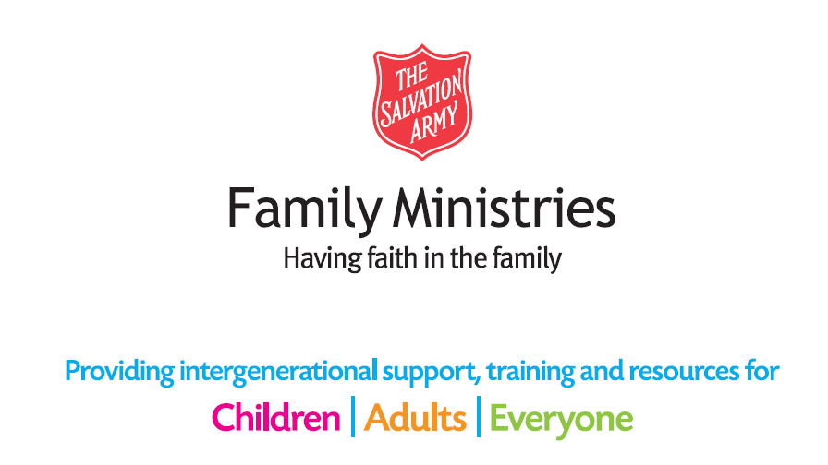

Poem

Easter Questions

Would I have sung hosanna as he rode along the way,
And strewn his road with branches in the dry heat of the day?
Would I have cheered and shouted as his donkey passed me by,
Proclaiming him as Lord and King as loud as I could cry?

Would I have championed Jesus as he cleansed God’s house of prayer,
Or hid away embarrassed at this thing that he did dare?
Would I have watched astounded as the Temple courts he cleared,
And joined in with the traders and the priests as they all jeered?

Would I have heard his teaching with an open mind and heart,
Or would I, like the Pharisees, have questioned every part?
Would I have tried to test him asking questions aimed to trick,
And spread untruthful rumours ’til the lies began to stick?

Would I have let the Servant-King stoop down and wash my feet,
Or understood his blessing as he broke the bread to eat?
Would I have been the one who could the Lord of all betray,
Or fall asleep while waiting when he’s asked me just to pray?

When Jesus was arrested would I too have drawn my sword,
Or would I have been tempted to deny him as my Lord?
Would I have shouted ‘Crucify!’ and spat upon his face,
And watched the King of Glory as he hung there in disgrace?

Could I have crowned him with those thorns or nailed him to that tree?
Would I have seen that it was love that held him there, for me?
But when he cried, ‘Forgive them, for they know not what they do’,
He knew it was the only way to save me and save you.

Rachel Gotobed

QUIZ

Easter Quiz
Circle the answer you think is right:
1. In which year was the word chocolate first recorded in English?
a) 1558 b) 1604 c) 1666 d) 1708
2. Which of the following is used in Northern Canada as a term for a group of rabbits?
a) Fluffle b) Muffle c) Duffle d) Puffle
3. How many boxes of chocolates did Queen Victoria send to Boer War soldiers on 1 January 1900?
a) None b) 100 c) 1,000 d) 100,000
4. What is the name given to the last two weeks of Lent?
a) Holy Weeks b) Passiontide c) Advent d) Easter
5. How many times round Britain would all the chocolate buttons sold in a year in the UK go?
a) Once b) Three times c) 10 times d) 20 times
6. In which ocean is Easter Island?
a) Pacific b) Atlantic c) Indian d) Arctic
7. How many times does the word ‘Easter’ occur in the King James Version of the Bible?
a) 1 b) 12 c) 19 d) 26
8. From which country does the Easter Lily originate?
a) China b) Fiji c) Japan d) India
9. What is the record for most yolks ever found in a chicken’s egg?
a) 4 b) 6 c) 9 d) 12
10. What percentage of annual chocolate sales in the UK do Easter eggs account for?
a) 4% b) 6% c) 8% d) 10%

QUIZ ANSWERS

Easter Quiz Answer Sheet
Underline or circle the answer you think is right
1. In which year was the word chocolate first recorded in English?
a) 1558 b) 1604 c) 1666 d) 1708
2. Which of the following is used in Northern Canada as a term for a group of rabbits?
a) Fluffle b) Muffle c) Duffle d) Puffle
3. How many boxes of chocolates did Queen Victoria send to Boer War soldiers on 1 January 1900?
a) None b) 100 c) 1,000 d) 100,000
4. What is the name given to the last two weeks of Lent?
a) Holy Weeks b) Passiontide c) Advent d) Easter
5. How many times round Britain would all the chocolate buttons sold in a year in the UK go?
a) Once b) Three times c) 10 times d) 20 times
6. In which ocean is Easter Island?
a) Pacific b) Atlantic c) Indian d) Arctic
7. How many times does the word Easter occur in the King James Bible?
a) 1 b) 12 c) 19 d) 26
8. From which country does the Easter Lily originate?
a) China b) Fiji c) Japan d) India
9. What is the record for most yolks ever found in a chicken's egg?
a) 4 b) 6 c) 9 d) 12
10. What percentage of annual chocolate sales in the UK do Easter eggs account for?
a) 4% b) 6% c) 8% d) 10%

